**Mongo db Basic Creations**

1. Create a new database called student management.

>> **use student_management**

**OUTPUT: -**



1. Create a collection called students in the student management database.

>> **db.createCollection("students")**

**OUTPUT: -**



1. Insert at least five student records into the student’s collection. Each record should have the following fields:

* Student_ID (integer)
* name (string)
* age (integer)
* department (string)
* courses (array of strings)
* grade (string)

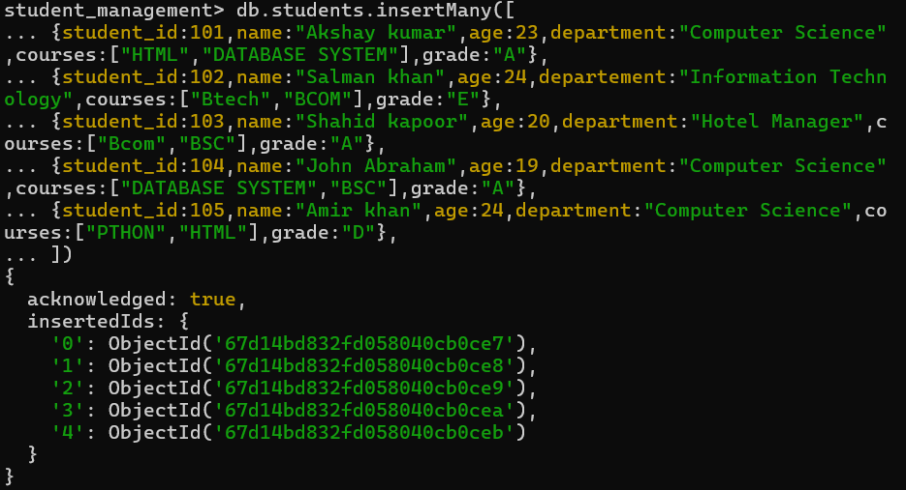

1. Query the Collection:

Write queries to perform the following tasks:

* Retrieve all students who are in the "Computer Science" department.

**>> db.students.find({department:"Computer Science"})**

**OUTPUT: -**

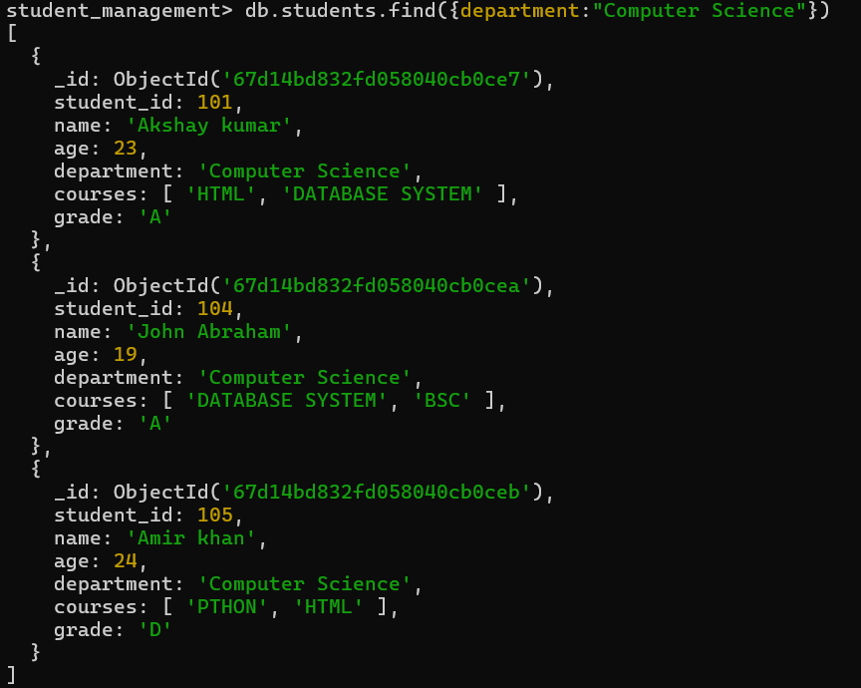

* Retrieve students who have an age greater than 21.

**>> db.students.find({age:{$gt:21}})**

**OUTPUT: -**

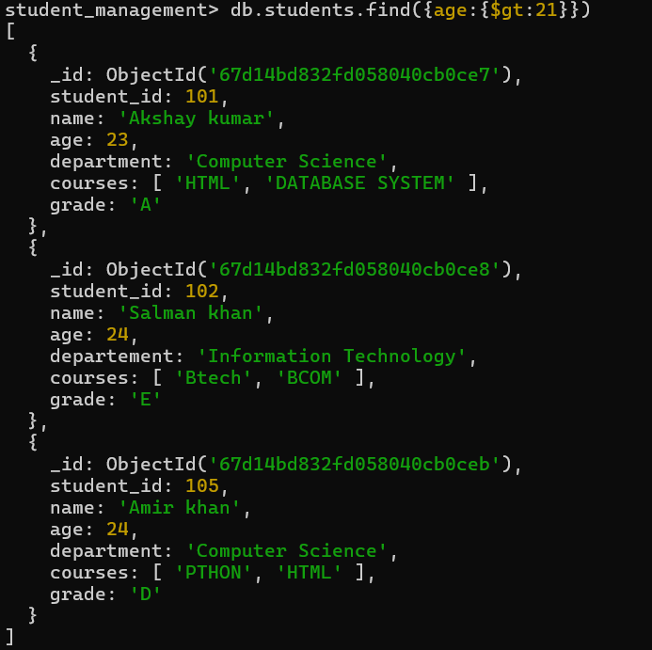

* Retrieve students who are taking the "Database Systems" course.

>> **db.students.find({courses:"DATABASE SYSTEM"})**

**OUTPUT: -**

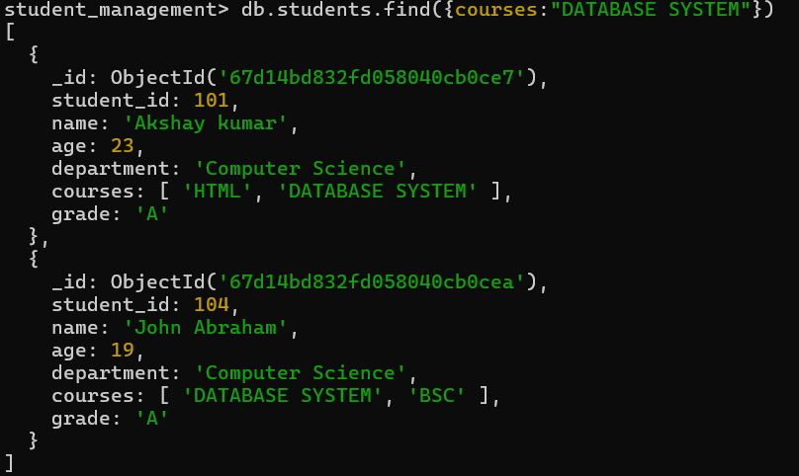

* Retrieve students with a grade of "A".

>> **db.students.find({grade:"A"})**

**OUTPUT: -**

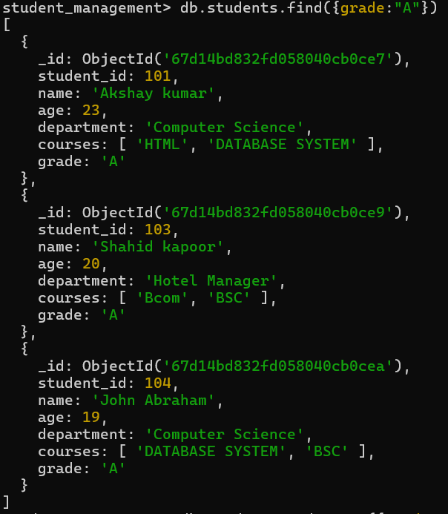

1. **Update Documents:**

* Update the age of a student with student_id 101 to 21.

>> **db.students.updateOne({student_id:101},{$set:{age:21}})**

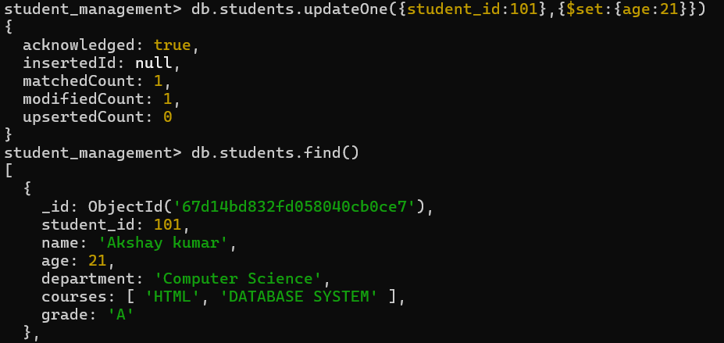

* Add a new course, "Machine Learning", to the courses array for students in the "Computer Science" department.

>> **db.students.updateMany({department:"Computer Science"},{$addToSet:{courses:"Machine Learning"}})**

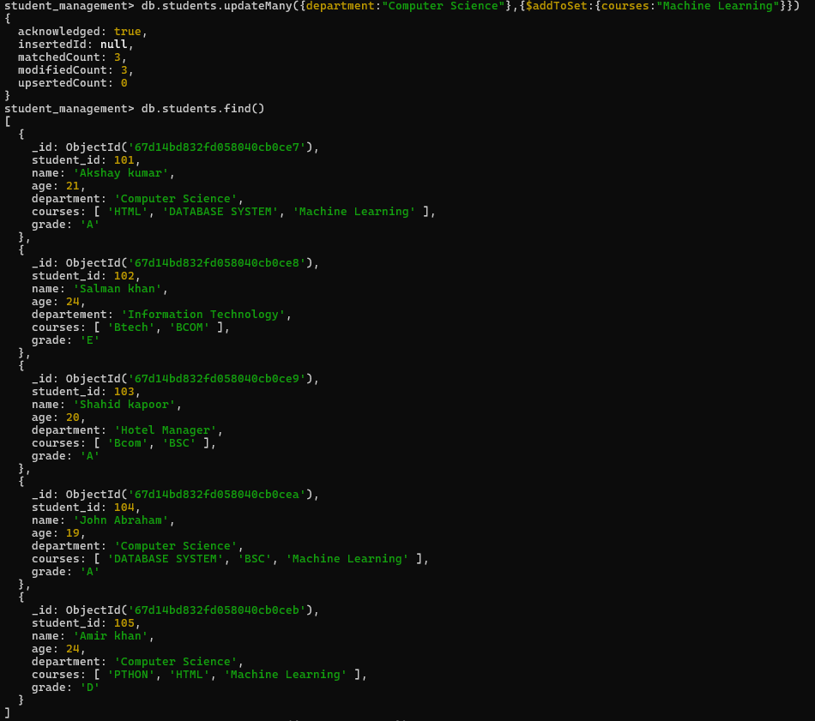

1. **Delete Documents:**

* Delete a student record with student_id 105.

>> **db.students.deleteOne({student_id:105})**

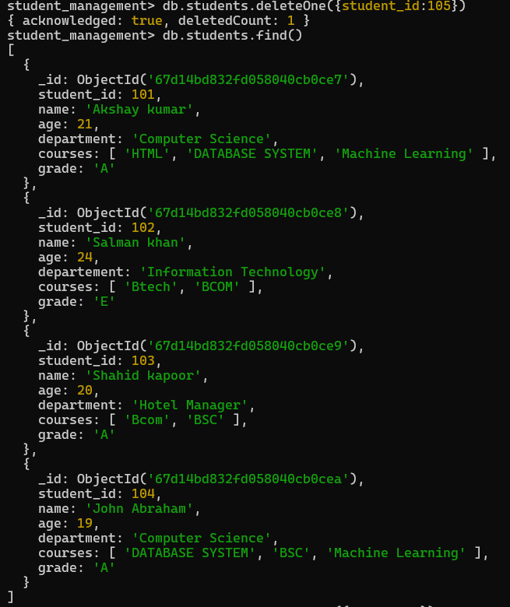

* Delete all students who have a grade lower than "C".

>> **db.students.deleteMany({grade:{$lt:"C"}})**

